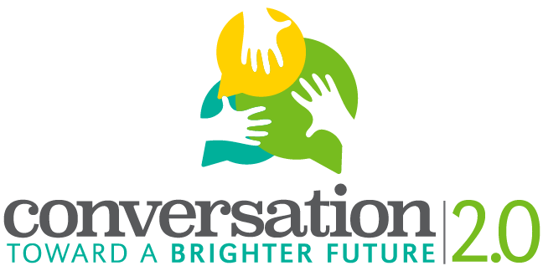
Host Organization: Southern Illinois University Edwardsville IRIS Center
Project Director: Dr. Jessica DeSpain, jdespai@siue.edu, 618-550-2151
Host School: (input school name and contact information about school facilitator)
Title of Project: Conversation Toward a Brighter Future 2.0
Project Period: May 1, 2018 to May 1, 2020

Southern Illinois University Edwardsville, in collaboration with (School Name here), and with funding from the National Endowment for the Humanities and the Mannie Jackson Center for the Humanities Foundation, is looking for residents of Madison County of different cultural backgrounds and age ranges to participate in the Conversation Toward a Brighter Future 2.0 Digital Storytelling Initiative.

The purpose of the initiative is:
- To learn how the personal and cultural stories we tell inform our perspectives on aging
- To understand how these stories impact our ability to speak across generations
- to enact a conversation that fosters better communication across generations.
- To give residents of Madison County the opportunity to share their experiences about aging and stages of life.
- (If you would like to, add your own goal related to how you’re framing the project).
Participants will:
- Participate in a preliminary meeting and subsequent interview by sharing their ideas, stories, and pictures with one of the project’s student facilitators.
- Work with student facilitator to craft and provide feedback on their digital story.
- Decide whether to share their digital story publicly, or keep it private.
If you have any questions about the project or woud like to participate, contact:
(Please include your teacher contact info in addition to any other information about how to participate)

