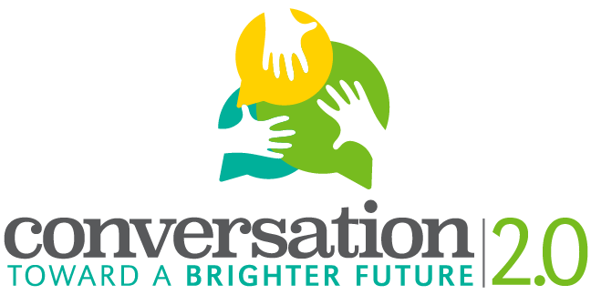
Photograph and Video Recording Permission Form
Host Organization: Southern Illinois University Edwardsville IRIS Center
Project Director: Dr. Jessica DeSpain, jdespai@siue.edu, 618-550-2151
Host School: (input school name)
Teacher Contact: (contact information for student facilitator’s teacher)
The purpose of the initiative is:
- To learn how the personal and cultural stories we tell inform our perspectives on aging.
- To understand how these stories impact our ability to speak across generations.
- To enact a conversation that fosters better communication across generations.
- To give residents of Madison County the opportunity to share their experiences about aging and stages of life.
- (If you would like to, add your own goal related to how you’re framing the project).

Name of Digital Storyteller: ____________________________________________
Name of Student Facilitator: __________________________________________________
- I understand the purpose of the digital storytelling project.
- I knowingly and voluntarily agree and consent to be photographed or video-recorded and to have my image used in the digital story created for this project.
- I understand my photographed or video-recorded image may be published, and I knowingly and voluntarily consent to my image being used in the following ways (check below for each use):
Yes | No | Use of Photographed or Video-Recorded Image | Exceptions/Comments
 |  | In a summary report for project recording purposes
 |  | On the CTBF 2.0 project website
 |  | On a YouTube Channel
 |  | At any presentation or knowledge exchange event
 |  | In any newsletter, news report, journal article and other visual, audio or written publication
 |  | For any education or teaching purpose

- I Do / Do NOT want my name to appear in relation to any publication of my photographed or video-recorded image.
- At any point, I can contact the project director to change the consent I have provided on this form.

__________________________________ ________________________________
Signature of Facilitator Signature of Participant

__________________________________ ________________________________
Date Date

