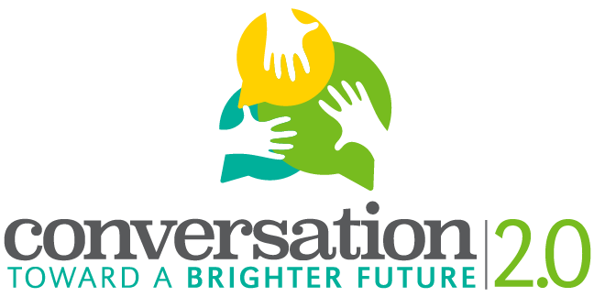
Digital Story Release Form
Host Organization: Southern Illinois University Edwardsville IRIS Center
Project Director: Dr. Jessica DeSpain, jdespai@siue.edu, 618-550-2151
Host School: (input school name)
Teacher Contact: (contact information for student facilitator’s teacher)
The purpose of the initiative is:
- To learn how the personal and cultural stories we tell inform our perspectives on aging.
- To understand how these stories impact our ability to speak across generations.
- To enact a conversation that fosters better communication across generations.
- To give residents of Madison County the opportunity to share their experiences about aging and stages of life.
- (If you would like to, add your own goal related to how you’re framing the project).

Name of Digital Storyteller: ____________________________________________
Name of Digital Story: ________________________________________________
Name of Student Facilitator: __________________________________________________
- I understand the purpose of the digital storytelling project.
- I knowingly and voluntarily agree and consent to publicly screening my above-titled digital story, distributing the written script of my digital story, or displaying images from my digital story in the following way (check either yes or no for each use):
Yes | No | Use of Photographed or Video-Recorded Image | Exceptions/Comments
 |  | In a summary report for project recording purposes
 |  | On the CTBF 2.0 project website
 |  | On a YouTube Channel
 |  | At any presentation or knowledge exchange event
 |  | In any newsletter, news report, journal article and other visual, audio or written publication.
 |  | For any education or teaching purpose

- I Do / Do NOT want my name to appear in relation to any publication of my digital story.
- I will review the digital story during the production process and approve it for inclusion in the project prior to its distribution in any of the ways I’ve consented to above.
- At any point, I can contact the project director to change the consent I have provided on this form.
__________________________________ ________________________________
Signature of Student Facilitator Signature of Participant

__________________________________ ________________________________
Date Date

