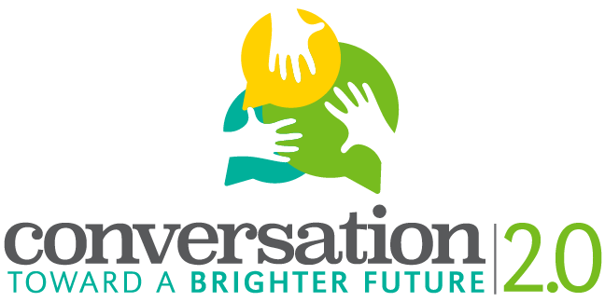
Consent Form
Host Organization: Southern Illinois University Edwardsville IRIS Center
Project Title: Conversation Toward a Brighter Future 2.0
Project Director: Dr. Jessica DeSpain, jdespai@siue.edu, 618-550-2151
Host School: (input school name)
Teacher Contact: (contact information for student facilitator’s teacher)
The purpose of the initiative is:
- To learn how the personal and cultural stories we tell inform our perspectives on aging.
- To understand how these stories impact our ability to speak across generations.
- To enact a conversation that fosters better communication across generations.
- To give residents of Madison County the opportunity to share their experiences about aging and stages of life.
- (If you would like to, add your own goal related to how you’re framing the project).

Name of Digital Storyteller: ____________________________________________

Name of Facilitator: __________________________________________________

- I, the storyteller, will participate in a preliminary 20-minute meeting and subsequent 45-minute interview to share ideas, stories, and pictures with the student facilitator.
- I will provide feedback on the student facilitator’s storyboard after they have shared it with me in a format of my choosing.
  - e-mail
  - in-person (30-minute meeting)
- I will allow the CTBF 2.0 project team to write a summary report that may be shared with funders and others interested in learning about the project.
- I can decide whether to share my digital story publicly or keep it private.
- My participation in the project is voluntary. I may withdraw my agreement to participate in the project at any time, for any reason, without penalty of any kind.
__________________________________ ________________________________
Signature of Storyteller Signature of Student Facilitator

__________________________________ ________________________________
Date Date

